ASSIGNMENT
24MCAT103-Digital Fundamentals and Computer Architecture 24MCAT107-Advanced Software Engineering

Submitted by: ANJALI SUNIL
Roll no:17
RMCA S1

Simulating Cache Memory Mapping and Replacement Algorithms using Git Collaboration

Scenario: You are part of a development team tasked with creating a Cache Simulation Tool that models the behaviour of different cache mapping functions (Direct, Associative, Set Associative) and cache replacement algorithms (FIFO, LRU, LFU).

Part A – 24MCAT103-Digital Fundamentals and Computer Architecture Component (Simulation Design)

PROGRAM

def fifo(pages, frames):
memory = []
page_faults = 0
index = 0

print("\n--- FIFO Page Replacement ---")
for p in pages:
if p not in memory:
page_faults += 1
if len(memory) < frames:
memory.append(p)
else:
memory[index] = p
index = (index + 1) % frames
print(f"Page {p}: {memory}")
return page_faults

def lru(pages, frames):
memory = []
page_faults = 0

print("\n--- LRU Page Replacement ---")
for i, p in enumerate(pages):
if p not in memory:
page_faults += 1
if len(memory) < frames:
memory.append(p)
else:
# Find LRU page
last_used = []
for m in memory:
if m in pages[:i]:
last_used.append(pages[:i][::-1].index(m))
else:
last_used.append(float('inf'))
replace_index = last_used.index(max(last_used))
memory[replace_index] = p
print(f"Page {p}: {memory}")
return page_faults

def optimal(pages, frames):
memory = []
page_faults = 0

print("\n--- Optimal Page Replacement ---")
for i, p in enumerate(pages):
if p not in memory:
page_faults += 1
if len(memory) < frames:
memory.append(p)
else:
future_use = []
for m in memory:
if m in pages[i+1:]:
future_use.append(pages[i+1:].index(m))
else:
future_use.append(float('inf'))
replace_index = future_use.index(max(future_use))
memory[replace_index] = p
print(f"Page {p}: {memory}")
return page_faults

def main():
while True:
print("\n====================================")
print(" PAGE REPLACEMENT ALGORITHMS MENU")
print("====================================")
print("1. FIFO")
print("2. LRU")
print("3. Optimal")
print("4. Exit")

choice = input("Enter your choice (1-4): ")

if choice == '4':
print("Exiting program.")
break

# Input section
pages = list(map(int, input("Enter page reference string (space-separated): ").split()))
frames = int(input("Enter number of frames: "))

if choice == '1':
faults = fifo(pages, frames)
print(f"Total Page Faults (FIFO): {faults}")

elif choice == '2':
faults = lru(pages, frames)
print(f"Total Page Faults (LRU): {faults}")

elif choice == '3':
faults = optimal(pages, frames)
print(f"Total Page Faults (Optimal): {faults}")

else:
print("Invalid choice! Please enter 1-4.")
if __name__ == "__main__":
main()

OUTPUT
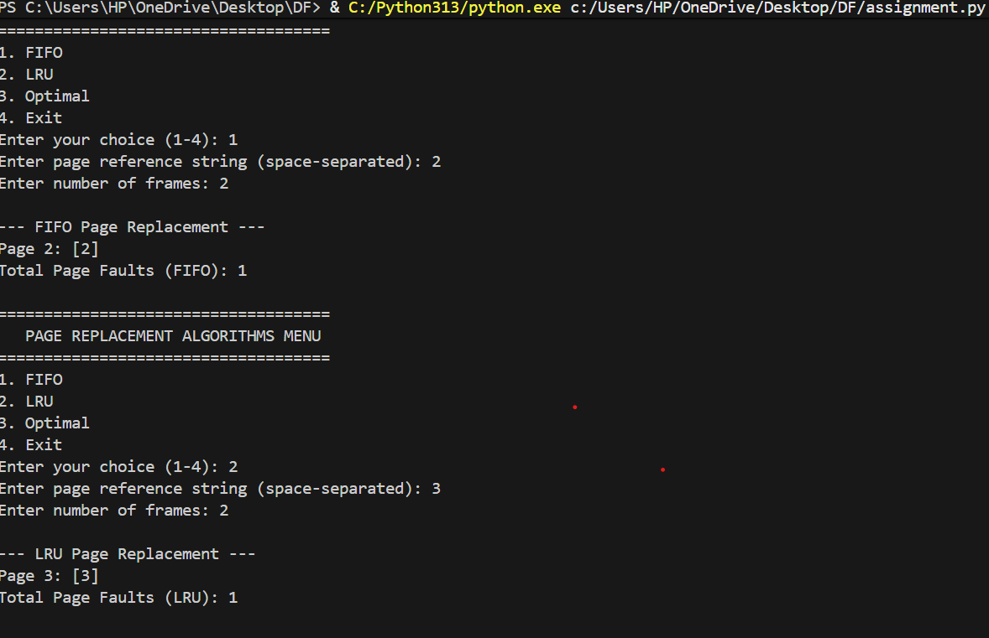

ALGORITHM

Algorithm FIFO(pages, frames):

1. Initialize an empty list MEMORY
2. Set PAGE_FAULTS = 0
3. Set INDEX = 0 // To track the oldest page
4. For each page P in PAGES:
a. If P is NOT in MEMORY:
i. PAGE_FAULTS = PAGE_FAULTS + 1
ii. If MEMORY size < FRAMES:
Append P to MEMORY
Else:
Replace MEMORY[INDEX] with P
INDEX = (INDEX + 1) mod FRAMES
b. Print current MEMORY state
5. Return PAGE_FAULTS

Algorithm LRU(pages, frames):

1. Initialize an empty list MEMORY
2. Set PAGE_FAULTS = 0
3. For each index i and page P in PAGES:
a. If P is NOT in MEMORY:
i. PAGE_FAULTS = PAGE_FAULTS + ii. If MEMORY size < FRAMES:
Append P to MEMORY
Else:
For each page M in MEMORY:
If M exists in PAGES before index i:
Calculate how long ago it was last used
Else:
Set last used time = infinity

Find REPLACE_INDEX having maximum last used time
Replace MEMORY[REPLACE_INDEX] with P

b. Print current MEMORY state

4. Return PAGE_FAULTS

Algorithm Optimal(pages, frames):

1. Initialize an empty list MEMORY
2. Set PAGE_FAULTS = 0

3. For each index i and page P in PAGES:
a. If P is NOT in MEMORY:
i. PAGE_FAULTS = PAGE_FAULTS + 1

ii. If MEMORY size < FRAMES:
Append P to MEMORY
Else:
For each page M in MEMORY:
If M appears again in PAGES after index i:
Compute how far in the future it will be used
Else:
Set future use distance = infinity

Find REPLACE_INDEX having maximum future use distance
Replace MEMORY[REPLACE_INDEX] with P

b. Print current MEMORY state

4. Return PAGE_FAULTS
Algorithm MAIN:

1. Loop forever:
a. Display menu:
1. FIFO
2. LRU
3. Optimal
4. Exit

b. Read user choice

c. If choice = 4:
Print "Exiting program" and break

d. Read page reference string
e. Read number of frames

f. If choice = 1:
Call FIFO and print total page faults
Else if choice = 2:
Call LRU and print total page faults
Else if choice = 3:
Call Optimal and print total page faults
Else:
Print "Invalid choice"

2. End

FLOW DIAGRAM EXPLANATION

The flow diagram illustrates the working process of page replacement in an operating system. When a page request is generated, the system first checks whether the requested page is already present in memory. If the page is found, normal execution continues without any interruption. However, if the page is not in memory, a page fault occurs, indicating that the operating system must load the page from secondary storage. The system then checks whether a free memory frame is available. If there is an empty frame, the new page is simply loaded into it. If no free frame exists, the operating system must apply a page replacement algorithm—such as FIFO, LRU, or Optimal—to determine which existing page should be removed. This chosen page is called the victim page. After the victim page is selected, it is replaced with the new page, and the program execution continues. This entire flow ensures efficient use of limited physical memory while maintaining smooth process execution.
FLOW DIAGRAM

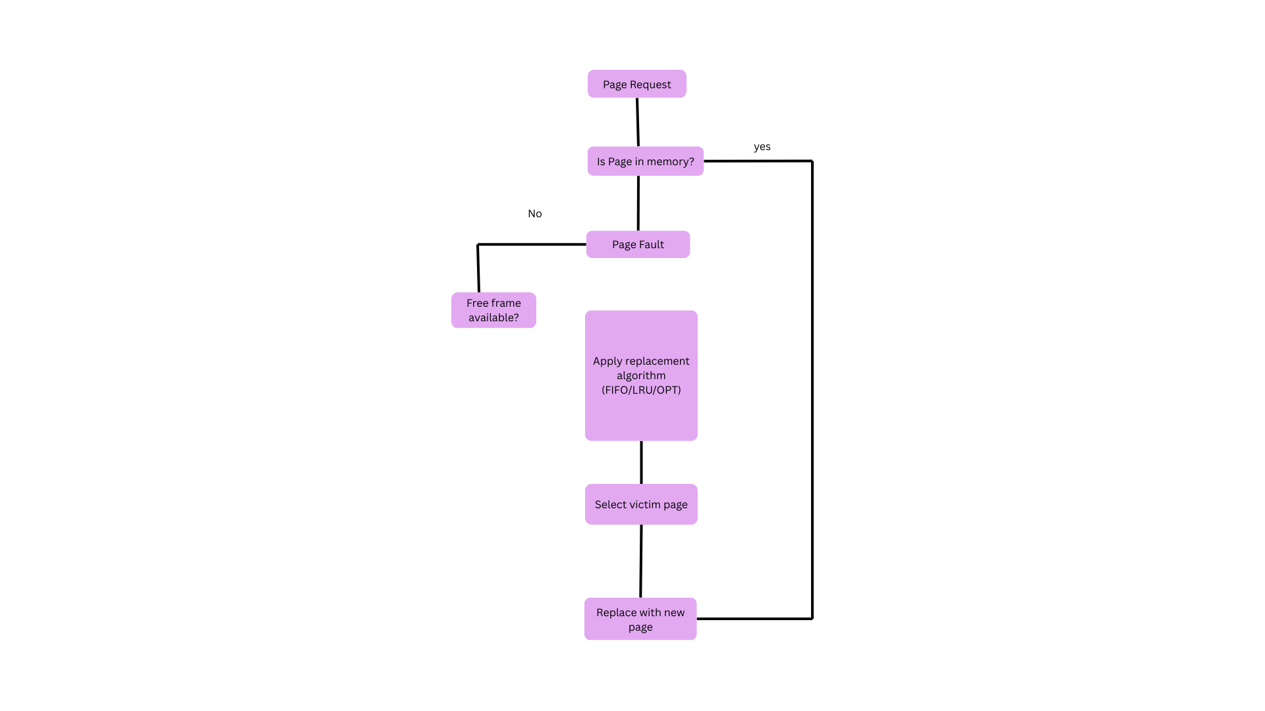

REPORT

This assignment integrates concepts from computer architecture and software engineering by developing a Cache Simulation Tool that demonstrates how cache memory handles page requests using FIFO, LRU, and LFU replacement algorithms. The simulation is implemented in Python and allows users to input a page reference string and frame size. Based on the selected algorithm, the system processes each page request, identifies page hits and faults, and determines the appropriate page to replace when memory frames are full.
The FIFO algorithm replaces the oldest page, LRU replaces the least recently used page, and LFU replaces the least frequently used one. The implemented program includes clear pseudocode, algorithmic steps, and a flow diagram illustrating the decision-making process. A visual workflow created using Canva highlights the operational sequence—from page request to replacement selection—improving conceptual understanding.
From the software engineering perspective, Git was used for collaboration. Team members created branches, committed code updates, resolved conflicts, and merged features into the main repository. This process strengthened practical skills in version control, documentation, and teamwork. The assignment successfully connected theoretical learning with real-world development practices.

REFLECTION

The implementation of page replacement algorithms such as FIFO, LRU, and LFU provided a deeper understanding of how operating systems manage memory efficiently. Converting theoretical concepts into software logic allowed me to visualize the behaviour of page faults, frame allocation, and victim page selection. Instead of just learning definitions from textbooks, writing the program helped me understand why certain algorithms perform better in specific scenarios. For example, implementing LRU required tracking recent usage, while LFU involved maintaining frequency counts—both of which reinforced how real systems prioritize memory management. The flow diagrams and workflows further clarified how a page request moves through different decision steps inside the cache.
Using Git for project collaboration was another valuable learning experience. Creating branches for separate features, committing changes, and merging them into the main branch helped simulate a real development environment. Git also ensured proper version management, allowing us to track modifications, revert mistakes, and maintain a clean project history. Working with GitHub increased team coordination and avoided code conflicts by isolating tasks across branches.
There were several challenges throughout the assignment. Designing the algorithms without errors, understanding merge conflicts, and maintaining consistent documentation required patience and practice. Sometimes code pushed from multiple branches caused conflicts that needed careful resolution. However, overcoming these difficulties taught me the importance of clear commit messages, frequent updates, and proper branching strategies. Overall, this assignment strengthened both my technical and collaborative skills, combining theoretical concepts with practical software engineering practices.

